Psychology 102: Sensation & Perception
Tu,Th 12:30-1:50, Solis Hall 107

Prof. David H. Peterzell, Ph.D., Ph.D. | Office: 3578 Mandler Hall | Hrs: Tu, Th, 2:05-3:30 –  Tu- Café Roma, Th- The Grove  Some Saturdays (TBA): 1:00-3:00 Café 976 in PB  And by appointment  Additional times announced weekly
Phone: 858-453-1058 | Email: peterzel@psy.ucsd.edu | URL: http://david.peterzell.org

Grad T.A.  M. Colin Ard | Office: Mandler 2554 | Hrs: Tu 11-12 a.m.  And by appointment | Email:  mcard@psy.ucsd.edu
Grad T.A.  Anton Navarro | Office: McGill B-148 | Hrs: M, W 2:30 – 3:30 | Email: anavarro@psy.ucsd.edu
Undergrad T.A. Melanie Kaelberer | Office: TBD | Hrs: TBD | Email:  mkaelber@ucsd.edu
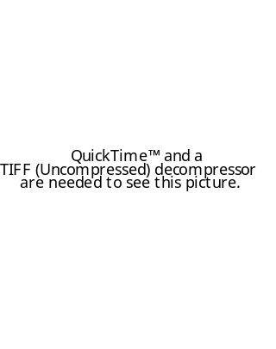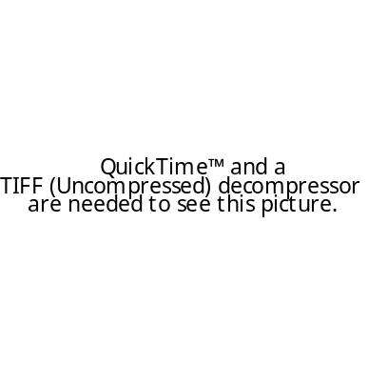
NEW Textbook (required): Sensation and Perception (2005, First Edition), by Wolfe, Kluender, Levi, Bartoshuk, Herz, Klatzky & Lederman $105 in the book store.
NEW CD-ROM with high quality demos (optional): PsyCog:Explorations in Perception and Cognition (2006, First Edition), by Wyttenbach Order online. 19.95 minus 10% student discount. 15% if you order 3.

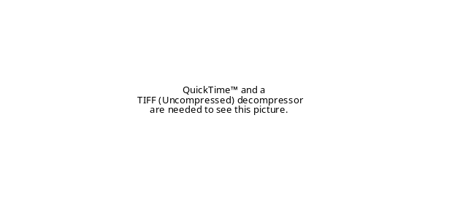
Class Websites: (1) UCSD’s WEBCT http://webct.ucsd.edu. This site will provide Powerpoint presentations, discussion boards, grades, a place to write us or your classmates, a place to provide feedback, and more. This is a great place to ask general questions and have them answered quickly. (2) Student Website for the textbook, Sensation and Perception. This site provides readings, demonstrations, and sample questions that demonstrate key points from the lecture and textbook. The essays on the site are optional.
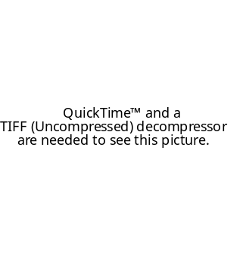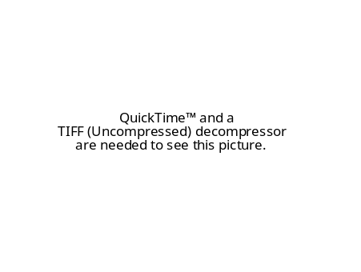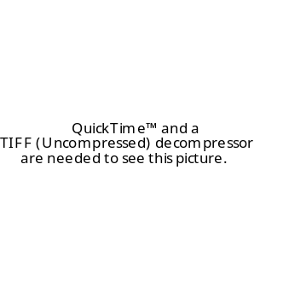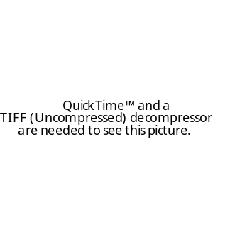
Course overview: By examining the sensory systems that allow us to see, hear, feel, smell, and taste, this course examines the complex and profound relationships between mind, matter and brain; between psychological, physical and neural realities. As such, it integrates knowledge from psychology, neuroscience, physics, chemistry, philosophy, and cognitive science. The content of this course overlaps considerably with the content of Cog Psy 101A (Sensation and Perception). This course is designed to cover relevant topics that are likely to appear on the GRE Psychology exam. This course emphasizes vision, and to a lesser extent hearing, as is typical in S&P courses.
Exams: There are 3 multiple-choice exams. Each exam consists of 50 questions/points. They are non-cumulative. All exams cover lectures and reading. Expect up to 40% of the questions to cover reading/website material not covered in lecture. You must show up on time to exams. Anyone who misses an exam receives zero points for that exam. The only exception is if you notify us as soon as possible and a valid excuse is verified, in which case the make-up exam may consist entirely of essay questions.
Sample Questions:
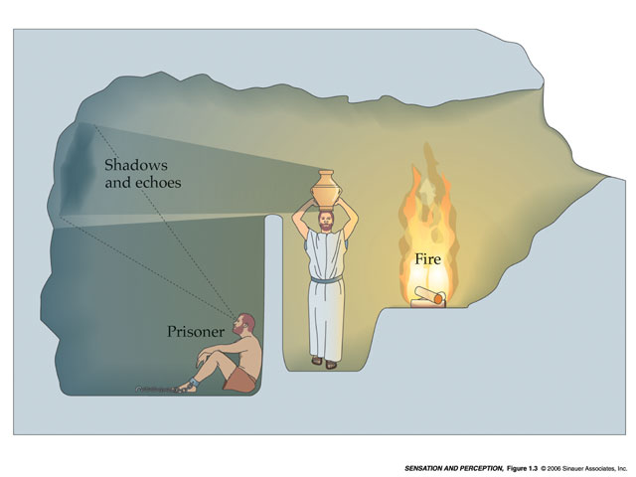 | 1. Plato’s “The Allegory in the Cave” (shown) depicts | a. a world perceived through the senses.  b. the idea of people depending on each other.  c. neuronal activity.  d. the psychology of human beings.
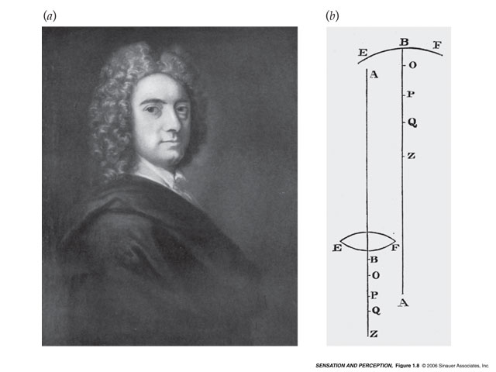 | 2. The idea that the mind is the true reality, and that objects exist only as aspects of the mind’s awareness is known as | a. mentalism.  b. perception.  c. dualism.  d. empiricism.
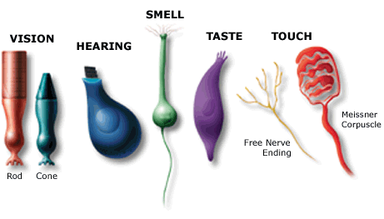 | 3. Sensory transducers are | a. external stimuli.  b. receptors that sense energy.  c. used to transfer energy from one person to another.  d. receptors that convert physical energy into neural activity.

Grading: Your final grade will be determined by simply adding up your 3 test scores and seeing where you stand relative to others. The mean total score will be a B-. Roughly, the top 10% will receive an A, the next 10% an A-, the next 40% will receive some sort of B, and many of the rest will receive some sort of C. These percentages do not take into account extra credit.
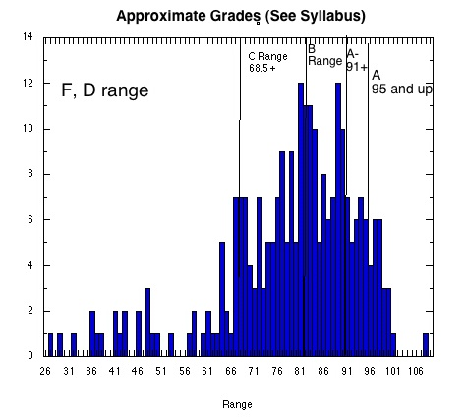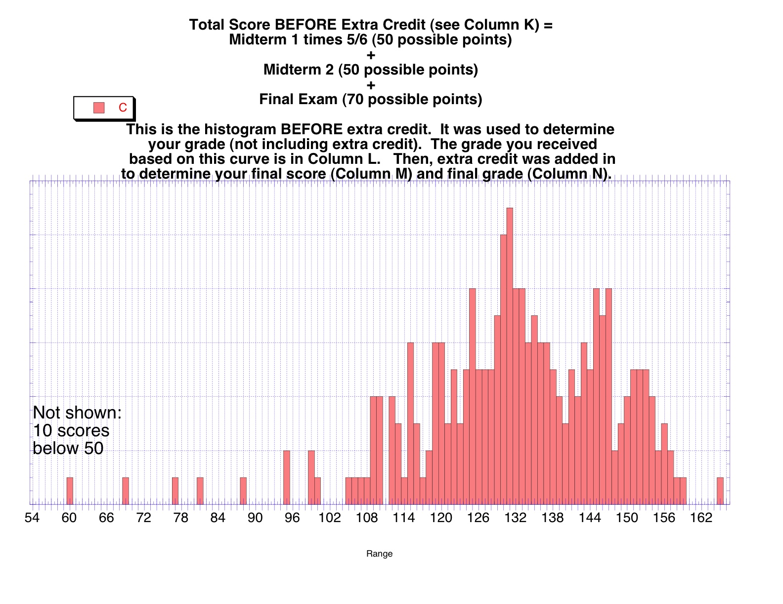
Examples – grade histograms from Peterzell’s UCSD Psych 105 class
Extra credit: You can earn extra credit by participating in UCSD psychology experiments advertised on the Web (see class handout). You will earn 2 points for each hour of credit, 6 points maximum. Failing to show up for an experiment you signed up for will cost you credit. Your final grade must be at least a C- to receive the credit. Completing the extra credit gives you a good chance of moving up 1/3 of a grade (e.g., from a B+ to an A-). The link for scheduling experiments is: http://experimetrix.com/ucsd/. Problems or questions? Contact Psychology Student Services Office, 1553 Mandler Hall
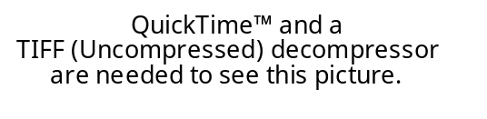
Adding the Course: Enrollment is limited to 300 students. To find out if the course is or is not full, contact Psychology Student Services Office, 1553 Mandler Hall. It is not recommended that you add the course after the first week if you missed the first week’s lectures.
Special Needs: Students with documentable special needs should contact the instructor or one of the TAs by the end of the first week. Waiting longer is not appropriate, and documentation needs to be provided prior to exam time. Documentation must come from an appropriate professional. Required accommodations will be made for these students, as required by law.

Schedule and Assignments: The exam dates are not subject to change. The dates that topics are presented may vary somewhat.
Week | Date | Topic | Chapter | S&P Website
1 | Apr 4 | Introduction/Psychophysics | 1 | 1
 | Apr 6 | Introduction/Psychophysics
2 | Apr 11 | The First Steps in Seeing | 2 | 2
 | Apr 13 | The First Steps in seeing
 |  | Spatial Vision | 3 | 3
3 | Apr 18 | Spatial Vision
 |  | Perceiving and Recognizing Objects | 4 | 4
 | Apr 20 | Perceiving and Recognizing Objects
 |  | Miscellaneous/Review
4 | Apr 25 | Exam 1 | 1 - 4
 | Apr 27 | The Perception of Color | 5 | 5
5 | May 2 | The Perception of Color
 |  | Space Perception and Binocular Vision | 6 | 6
 | May 4 | Space Perception and Binocular Vision
6 | May 9 | Motion Perception | 7 | 7
 | May 11 | Motion Perception
 |  | Attention and Scene Perception | 8 | 8
7 | May 16 | Attention and Scene Perception
 |  | Miscellaneous/Review
 | May 18 | Exam 2 | 5 - 8
8 | May 23 | Hearing: Physiology and Acoustics | 9 | 9
 | May 25 | Hearing: Physiology and Acoustics
 |  | Hearing in the Environment | 10 | 10
9 | May 30 | Hearing in the Environment
 |  | Music Perception (Colin)
 | June 1 | Touch | 12 | 12
10 | Jun 6 | Olfaction (Smell) | 13 | 13
 | Jun 8 | Taste | 14 | 14
 |  | Miscellaneous/Review
Final | Jun 13, Tu  11:30-2:30 | FINAL EXAM (not cumulative) | 9,10, 12-14 | 9, 10  12-14

